Open the "Foodmart_Data_Model.xlsx" worksheet that you saved on your desktop. This file was the finished product of your previous exercises. You should first complete all the other exercises and Quest before this one.

You should see all tables loaded under Data > Queries & Connections

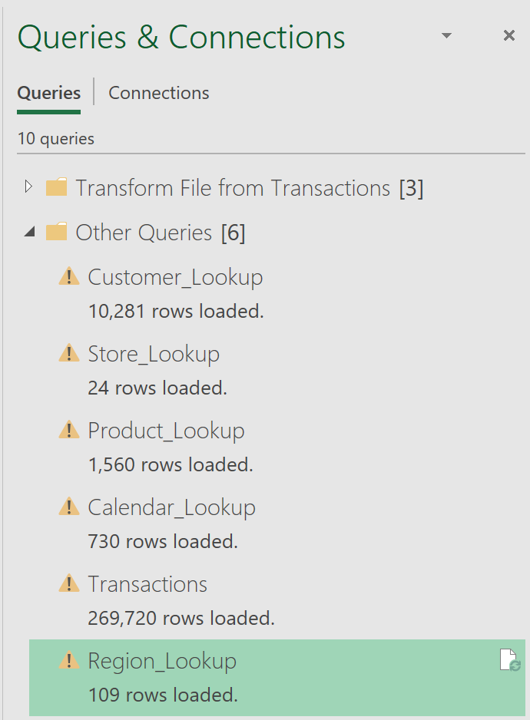



Go to your data model by pressing Power Pivot > Manage

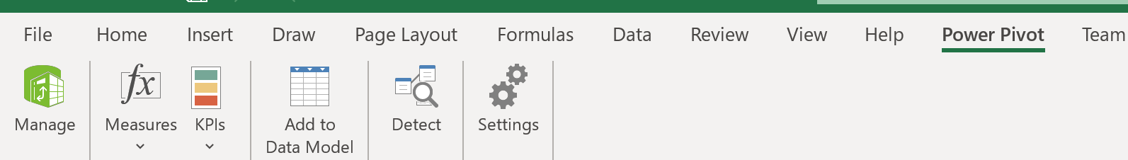



The screen below is displaying Region Lookup, yours may be different.

From here, click Diagram View

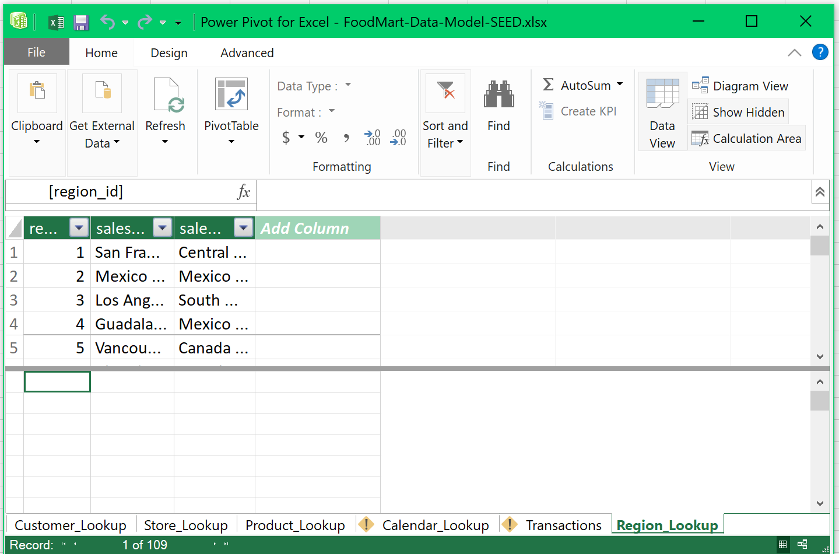



Rearrange your data model’s diagram view so it will be similar to the image below. Now, let’s build the first relation. Drag the product_id field from Transactions towards the product_id of Product_Lookup table. A one-to-many relationship will be created from the product table to the transactions table.

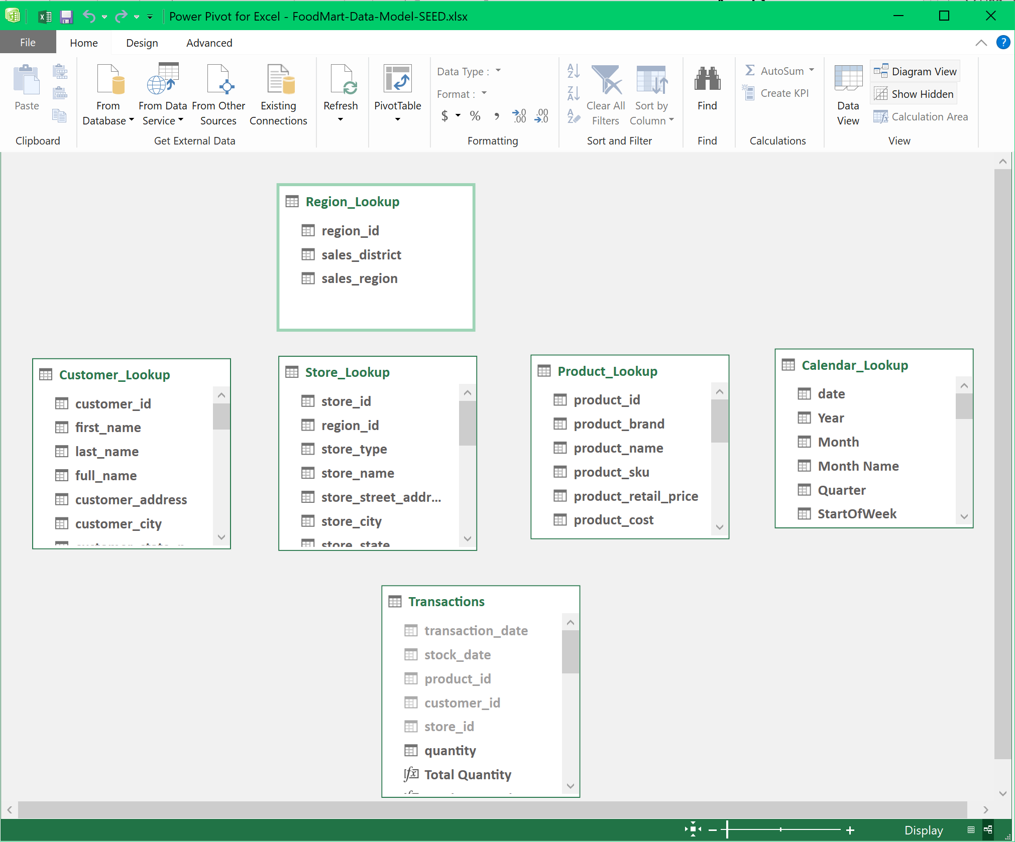



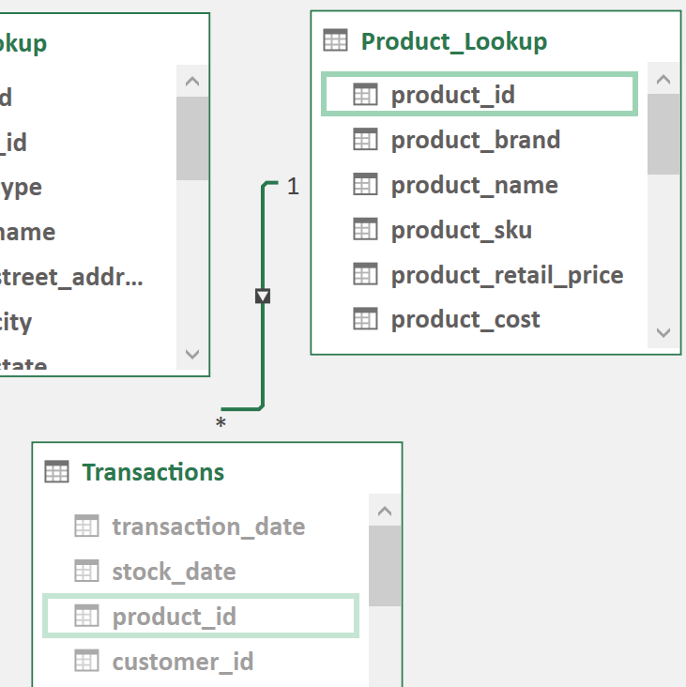

Congratulations, you’ve just built your first table relationship. Now let’s build the second relationship differently.

Go to Design > Create Relationship > Transactions for the first table > Customer_Lookup for the second table. Note how the data model knows that the foreign key customer_id of Transactions match the primary key customer_id of Customer_Lookup table. Click OK. Note the one-to-many relationship from Customer_Lookup to Transactions.

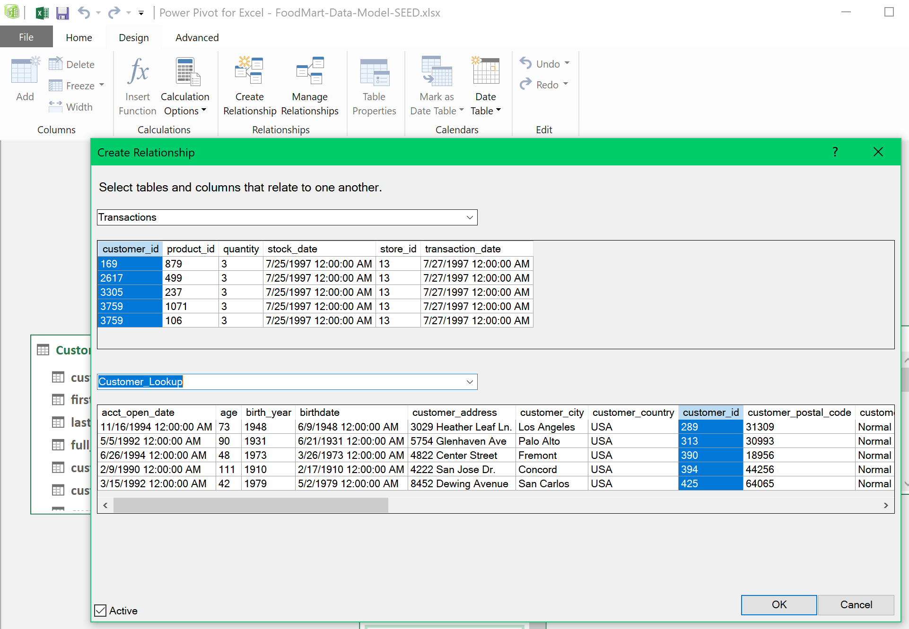



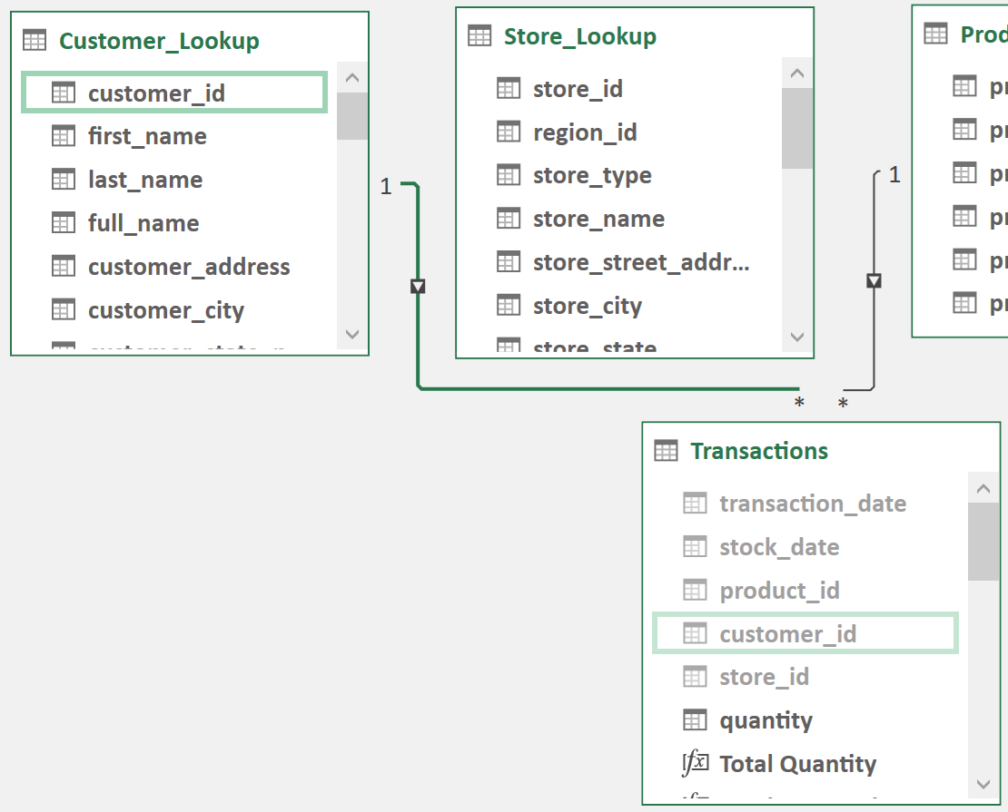

Your turn:

Build a one-to-many relationship between Store_Lookup table and Transactions via store_id field.

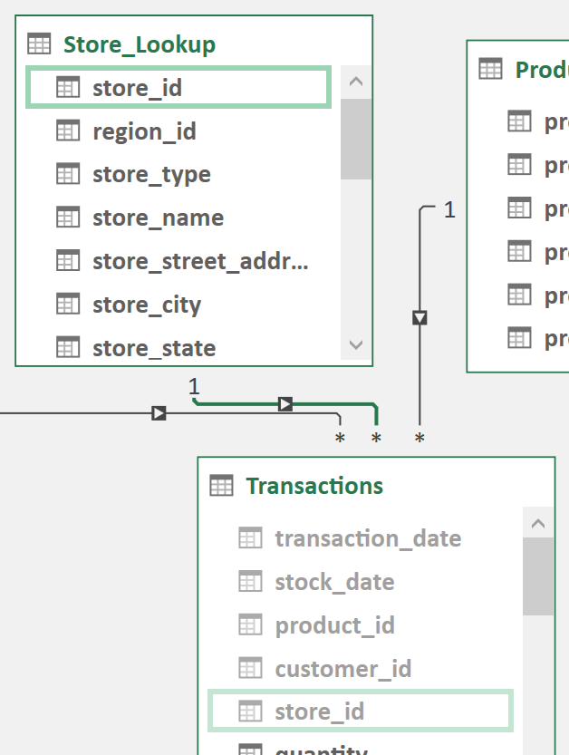

Next, build a one-to-many relationship between Calendar_Lookup date and Transactions’ transaction_date.

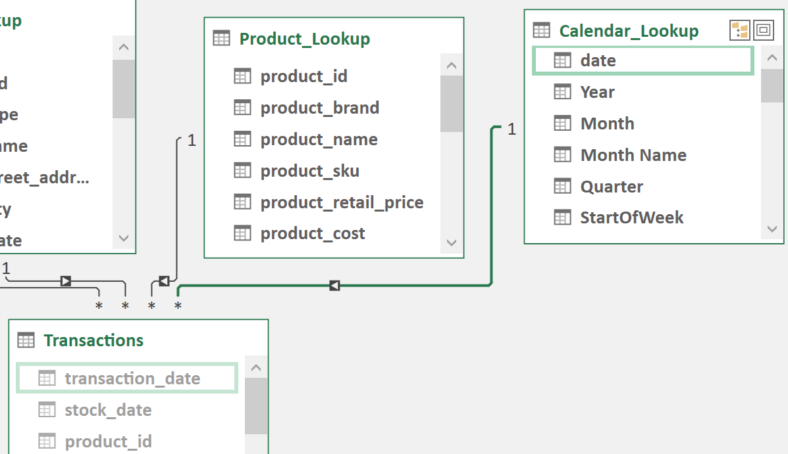

Finally, build a one-to-many relationship between Region_Lookup and Store_Lookup through region_id column.

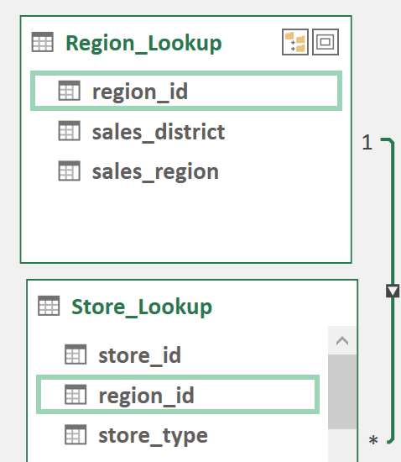

Your final entity relationship diagram (ERD) should resemble below:

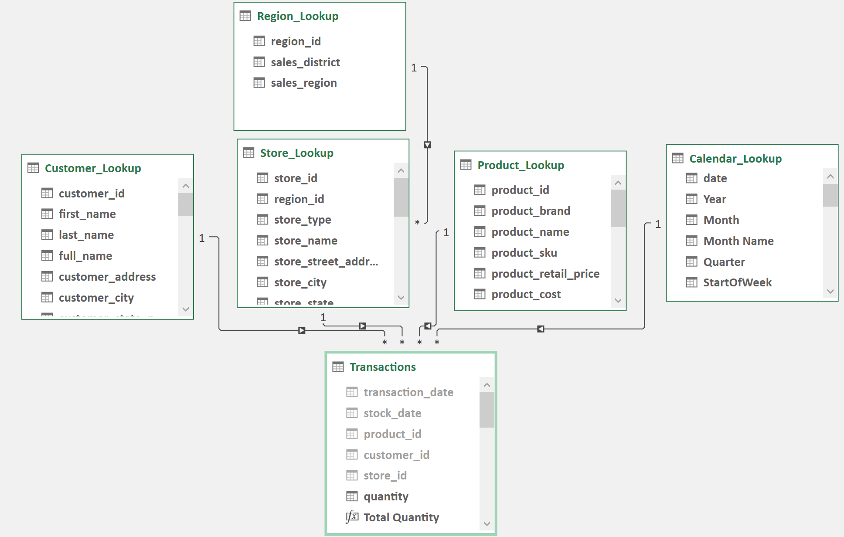

Save your work and reposition your screens so that Excel will be in the background and the data model window in front.

1. Take a snapshot using Window's Snipping Tool.
2. Make sure the system's date, your name, and the ERD of the data model’s diagram view are included in the image.
3. Submit to Canvas in PNG format.

